|  |  |
| --- | --- |
|  | SQE Project |
|  |  |
|  | Kashmala Ahmad  Alishba Shabbir  SE-5B |

Contents

**Testim Documentation Overview** 4

**Testim Overview** 4

**1. Introduction to Testim** 4

**Key Features:** 4

**2. Key Features of Testim** 4

**Feature Overview Table** 4

**3. Detailed Descriptions of Key Features** 5

**Fast Authoring** 5

**AI-Based Stabilization** 5

**Cross-Browser Testing** 5

**Customizable Reports** 5

**Smart Locators** 5

**Test Parameterization** 5

**Collaboration Tools** 5

**4.ScreenShots:** 6

Test Cases: 6

6

Properties: 7

7

Menu Bar: 7

7

8

**5. Learning Resources and Tutorials** 8

**Video Tutorials:** 8

**Written Guide:** 8

• testim-overview 8

• test-automation 8

**Testim Documentation Overview**

**Testim Overview**

**Testim** is a powerful tool for automating the testing of web applications. It leverages **artificial intelligence** to enhance the efficiency and effectiveness of the testing process. Below is a detailed overview of Testim and its features.

**1. Introduction to Testim**

**Testim** is an AI-powered test automation platform designed to help teams quickly create, execute, and maintain automated tests. It supports the entire testing lifecycle, from authoring to execution and maintenance, using AI to optimize and stabilize tests.

**Key Features:**

* **AI-Powered**: Uses machine learning to improve test stability.
* **Fast Authoring**: Quickly create tests using a visual editor or code.
* **Flexible Execution**: Run tests in the cloud or on-premises.
* **Detailed Reporting**: Provides in-depth reports and insights.

**2. Key Features of Testim**

**Feature Overview Table**

|  |  |
| --- | --- |
| **Feature** | **Description** |
| **Fast Authoring** | Create tests using a visual editor, ensuring quick and easy test development. |
| **AI-Based Stabilization** | Uses AI to identify and fix unstable tests, reducing false positives and maintenance efforts. |
| **Cross-Browser Testing** | Supports testing across multiple browsers to ensure compatibility and functionality. |
| **Customizable Reports** | Generate detailed and customizable reports for better insights and decision-making. |
| **CI/CD Integration** | Seamlessly integrates with CI/CD pipelines for continuous testing and deployment. |
| **Smart Locators** | Uses dynamic locators to identify UI elements, making tests more robust. |
| **Test Parameterization** | Allows parameterization of tests to run them with different data sets. |
| **Collaboration Tools** | Facilitates collaboration among team members with shared test cases and results. |

**3. Detailed Descriptions of Key Features**

**Fast Authoring**

Testim provides a user-friendly visual editor that allows testers to quickly create automated tests without the need for extensive coding knowledge. The platform also supports code-based test creation for more advanced users.

**AI-Based Stabilization**

Testim’s AI algorithms continuously analyze tests to identify patterns and stabilize tests by adjusting them based on historical data. This reduces the likelihood of test flakiness and ensures reliable test results.

**Cross-Browser Testing**

Testim supports running tests on various browsers, including Chrome, Firefox, Safari, and Edge. This ensures that web applications function correctly across different environments.

**Customizable Reports**

The platform provides detailed and customizable reports that highlight test results, failures, and performance metrics. These reports help teams quickly identify issues and understand test coverage.

**Smart Locators**

Testim uses AI-powered smart locators to identify UI elements. These locators adapt to changes in the application’s UI, making tests more resilient to changes and reducing maintenance efforts.

**Test Parameterization**

Testim allows testers to parameterize tests, enabling them to run the same test with different sets of data. This feature is useful for testing various scenarios and data combinations.

**Collaboration Tools**

Testim includes features that facilitate collaboration among team members. Test cases and results can be shared, and team members can leave comments and feedback, improving communication and efficiency.

**4.ScreenShots:**

### Test Cases:

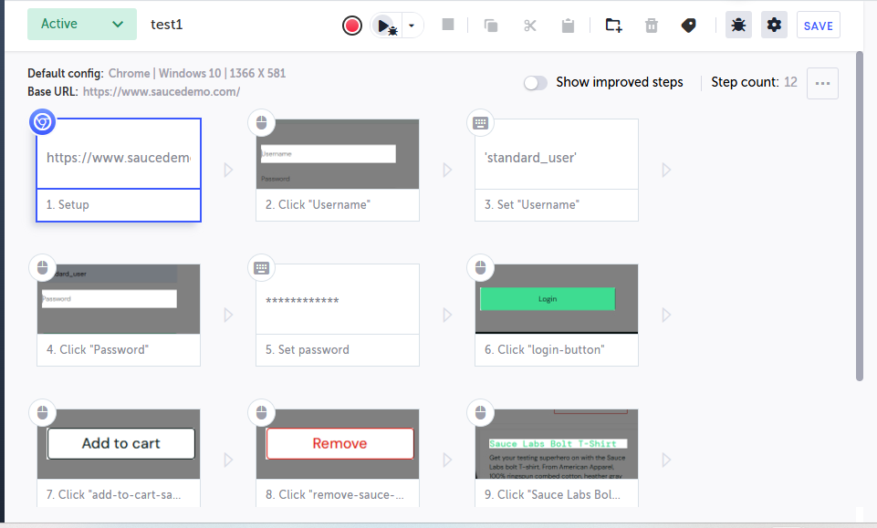

### Properties:

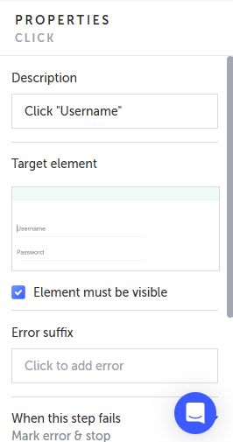

### Menu Bar:



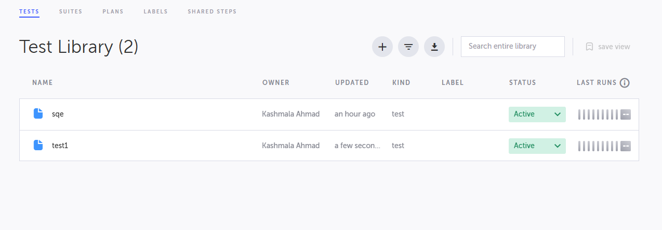

**5. Learning Resources and Tutorials**

**Video Tutorials:**

* [Introduction to Testim](https://youtu.be/duGCopo0bko?si=kEXA3a5r1rmkO7yc)
* [Tutorial](https://www.youtube.com/watch?v=hy2FoW70doI&list=PLhW3qG5bs-L-Fgaw6V6uRVL-oyv0dUSCm&form=MG0AV3)

**Written Guide:**

* [testim-overview](https://help.testim.io/docs/testim-overview)
* [test-automation](https://www.testim.io/blog/what-is-test-automation/)